|  |  |
| --- | --- |
| LIFE logo | **HOLY CROSS COLLEGE**  **SEMESTER 2, 2017**  **Question/Answer Booklet** |

Please place your student identification label in this box

11 PHYSICS

Student Name ___________________________________

Student’s Teacher __________________________________________

#### Time allowed for this paper

Reading time before commencing work: 10 minutes

Working time for paper: 3 hours

**Materials required/recommended for this paper**

To be provided by the supervisor

This Question/Answer Booklet

Data Sheet

***To be provided by the candidate***

Standard items: pens, pencils, eraser, correction fluid, ruler, highlighters

Special items: non-programmable calculators satisfying the conditions set by the School Curriculum and Standards Authority for this course

**Important note to candidates**

No other items may be taken into the examination room. It is **your** responsibility to ensure that you do not have any unauthorised notes or other items of a non-personal nature in the examination room. If you have any unauthorised material with you, hand it to the supervisor **before** reading any further.

**Structure of this paper**

|  |  |  |  |  |  |
| --- | --- | --- | --- | --- | --- |
| Section | Number of questions available | Number of questions to be answered | Suggested working time  (minutes) | Marks available | Percentage of exam |
| Section One:  Short answer | 12 | 12 | 50 | 59 | 33 |
| Section Two:  Extended answer | 7 | 7 | 90 | 91 | 50 |
| Section Three:  Comprehension  and data analysis | 2 | 2 | 40 | 30 | 17 |
|  |  |  | **Total** | 180 | 100 |

**Instructions to candidates**

1. The rules for the conduct of examinations at Holy Cross College are detailed in the College Examination Policy*.* Sitting this examination implies that you agree to abide by these rules.

2. Write your answers in this Question/Answer Booklet.

3. Working or reasoning should be clearly shown when calculating or estimating answers.

4. You must be careful to confine your responses to the specific questions asked and to follow any instructions that are specific to a particular question.

5. Spare pages are included at the end of this booklet. They can be used for planning your

responses and/or as additional space if required to continue an answer.

• Planning: If you use the spare pages for planning, indicate this clearly at the top of the

page.

• Continuing an answer: If you need to use the space to continue an answer, indicate in the original answer space where the answer is continued, i.e. give the page number.

Fill in the number of the question(s) that you are continuing to answer at the top of the

page.

6. Answers to questions involving calculations should be ***evaluated and given in decimal***

***form*.** It is suggested that you quote all answers to ***three significant figures***, with the

exception of questions for which estimates are required. Despite an incorrect final result,

credit may be obtained for method and working, providing these are ***clearly and legibly set***

***out***.

7. Questions containing the instruction *"estimate"* may give insufficient numerical data for their

solution. Students should provide appropriate figures to enable an approximate solution to

be obtained. Give final answers to a maximum of *two significant figures* and include appropriate units where applicable.

8. Note that when an answer is a vector quantity, it must be given with magnitude and direction.

9. In all calculations, units must be consistent throughout your working.

**Section One: Short response 33% (59 Marks)**

This section has **twelve** **(12)** questions. Answer **all** questions. Write your answers in the space

provided. Suggested working time for this section is 50 minutes.

**Question 1 (4 marks)**

(a) Describe the conditions required for a standing wave to form. (2 marks)

(b) Draw the standing waves in a:

(i) closed pipe resonating in its second mode of vibration. (1 mark)

(ii) string vibrating at its fourth harmonic. (1 mark)

**Question 2 (4 marks)**

1.00 x 102 g of ice is taken from a freezer where it is kept at -6.00°C. It is heated until it becomes water at 75.0°C. Calculate how much energy it has absorbed, assuming no energy leaves the system.

**Question 3 (6 marks)**

A 0.100 kg hockey puck is at rest. A force of 20.0 N acts on it for 0.200 s, which sets it in motion. Over the next 2.00 s, it encounters an average of 0.400 N frictional force. Lastly, a force of 24.0 N acts for 0.0500 s in the direction of motion. Calculate the puck’s final speed.

***(Hint: there are three separate calculations - show your working.)***

**Question 4 (5 marks)**

Four resistors are connected in a complex circuit to a 38.0 V battery.

19 Ω

24 Ω

8.0 Ω

P

5.4 Ω

Q

38.0 V

(a) Determine the total resistance of the 4 resistors between points P and Q in this circuit.

(3 marks)

(b) Determine the current that flows in the circuit. (2 marks)

**Question 5 (5 marks)**

Horsepower (hp) is an old unit to measure power, the rate at which work is done. The diagram below shows that 1.00 hp is needed to lift a 75.0 kg mass by 1.00 metre in 1.00 second.

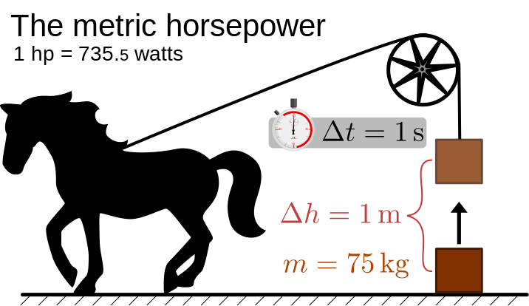

(a) Show by calculation that 1.00 hp = 735 W. (2 marks)

(b) If a 12.5 hp air-conditioner is working for 2 minutes 15 seconds, calculate how much work has been done. (2 marks)

**Question 6 (4 marks)**

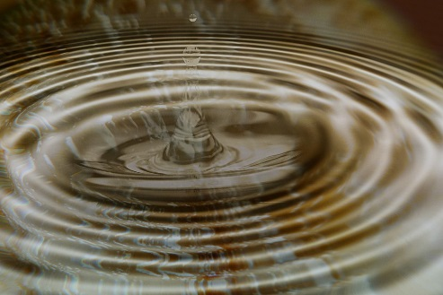A stone is dropped into a still pool of water. It generates 20 waves that spread out a distance of 10.0 m from where it entered the water. The outer wave covers the 10.0 m in a time of 5.00 s and the average height of the waves is 10.0 mm (crest-to-trough).

(a) Determine the wavelength and velocity of the waves.

(2 marks)

(b) Calculate the period of the water waves. (2 marks)

**Question 7 (6 marks)**

Sophie took 8.00 minutes to dry her hair with a hair dryer. During this period, the hair dryer drew a current of 5.50 A from a 2.40 x 102 V supply.

(a) Calculate much charge passed through the hair dryer in this time. (2 marks)

(b) Calculate the resistance of the heating coil of the hair dryer. (2 marks)

(c) Calculate the power rating of the hair dryer. (2 marks)

**Question 8 (5 marks)**

In an experiment to measure your reaction time, a partner drops a ruler through your open hand and you try to catch the ruler. The length from the start of the ruler to where you catch it can then be used to find your reaction time.

(a) Assuming the ruler starts at rest, derive a formula to show how you could calculate the reaction time as a function of length (displacement). (2 marks)

(b) A group of students collected the following data:

|  |  |
| --- | --- |
| **Trial** | **Distance ruler fell (mm)** |
| 1 | 46 |
| 2 | 44 |
| 3 | 38 |
| 4 | 32 |
| Average: |  |

Complete the table by calculating the average distance the ruler fell. (1 mark)

(c) Calculate the average reaction time as shown by the data above. (2 marks)

**Question 9 (4 marks)**

A person has decided to try indoor skydiving. A large aeroplane engine bolted to the ground provides a very high wind, on which participants can “fly”.

(a) Draw and clearly label two forces that act on a person whilst in “flight”. (2 marks)

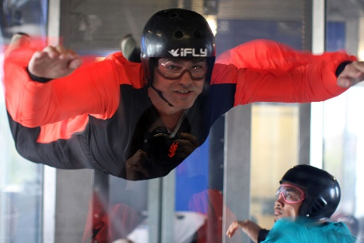

[Grab your reader’s attention with a great quote from the document or use this space to emphasize a key point. To place this text box anywhere on the page, just drag it.]

(b) If a 70.0 kg person wishes to remain at a constant height, calculate the force that the wind needs to apply to them. Be sure to show your working. (2 marks)

**Question 10 (7 marks)**

On the way to school, a student decides not to use the pedestrian bridge to cross a busy road, and decides instead to run across the road. He sees a car 1.00 x 102 m away travelling towards him, and is conﬁdent that he can cross in time.

(a) If the car is travelling at 105 kmh-1 and the student can run at 10.0 kmh-1, calculate their respective speeds in ms-1. (2 marks)

Car ___________________ Student ___________________

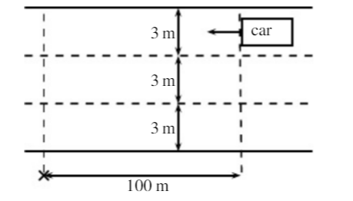(b) If the road has 3 lanes, and each lane is 3.00 m wide, how long will it take for the student to cross all three lanes, from kerb to kerb? (2 marks)

(c) If the car is travelling in the furthermost lane from the student, will he be able to cross all 3 lanes of the road safely? ***Provide a calculation as part of your reason.*** (3 marks)

Answer: ____________

Reason:

**Question 11 (5 marks)**

A 2.40 x 102 V electric kettle is used to heat 2.80 x 102 mL of water initially at 22.0 °C. The heating element draws a current of 1.80 A, and is left on for 3.00 minutes. Determine the final temperature of the water, assuming 85.0% efficiency.

**Question 12 (4 marks)**

In a game of ten-pin bowling, a person bowls a 10.5 kg bowling ball so that it hits the last remaining 1.00 kg bowling pin at 2.40 ms-1 and continues after the collision at 1.94 ms-1. The collision is head-on, so that all motion is in one-dimension. Calculate the speed of the pin immediately after the collision.

**End of Section One**

**This page has been deliberately left blank.**

**Section Two: Problem-solving 50% (91 Marks)**

This section has **seven (7)** questions. You must answer **all** questions. Write your answers in the

space provided. Suggested working time for this section is 90 minutes.

**Question 13 (14 marks)**

A solar camp shower is a device to heat water for a shower when other sources of energy are unavailable. The bag is simply hung in a sunny spot for a period of time. A typical camp shower would hold 20.0 litres of water.

(a) Explain why the bag is black in colour. (1 mark)

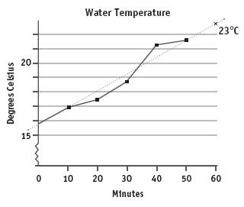

(b) Examine the graph to the right, which shows how on a certain day, the temperature of water changes with time.

(i) State and briefly explain ***one reason*** why the temperature of the water is not increasing at a constant rate.

(2 marks)

(ii) Use the graph’s line of best fit to calculate the average rate at which the water is heated*.* ***(Express your answer in oCmin-1.)*** (2 marks)

(iii) How long would it take to heat the water to 30.0 oC from time t = 0? (2 marks)

(c) Calculate the amount of energy 20.0 litres of water needs to absorb to be heated from

15.8 oC to 30.0 oC. (2 marks)

(d) The average amount of solar radiation received at the Earth's surface is 1.37 x 103 Wm-2 every second. The camp shower bag has an absorbing area of 0.400 m2.

(i) Calculate the rate at which solar energy falls on the bag. (2 marks)

(ii) If 100% of this energy was to go into heating water, how long would it take to heat

20.0 litres of water from 15.8oC to 30.0oC (3 marks)

**Question 14 (14 marks)**

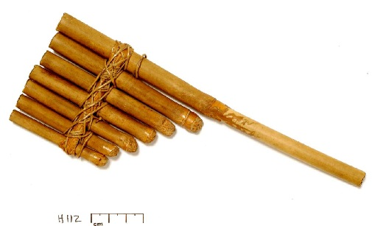

Panpipes, or pan flutes, can be traced back to Greek, Mayan, Native American, and many other ancient cultures. Although the sizes and styles differ across cultures, the basic design is a series of closed-end tubes of varying length, fixed together.

The sound is produced by blowing into the pipes and setting the column of air inside into motion. Once the wave pattern is stabilized it is known as a standing wave.

(a) Will the closed end of the tube always serve as a displacement node or an antinode? Briefly explain your answer in terms of interference of waves. (2 marks)

(b) Determine the relationship between the ***wavelength*** of the fundamental frequency (first harmonic) and the ***length*** of the tube. (1 mark)

(c) If a pipe of length 30.4 cm was made to resonate at its fundamental frequency (first harmonic), calculate the frequency of sound produced. (2 marks)

(d) The tube is now vibrating with a standing wave pattern of three antinodes and three nodes. State which harmonic this represents. Draw a particle displacement diagram below to aid your answer. (2 marks)

Harmonic: ____________

(e) A student wishes to make another pipe that produces sounds one octave above this (***i.e.*** ***twice its frequency***). Calculate the length pipe she will need to make. (2 marks)

(f) An internet guide to making your own panpipe suggests that each pipe is 9/8 the length of the previous. One of the pipes resonates at its ***third harmonic***, producing an A note of

440 Hz.

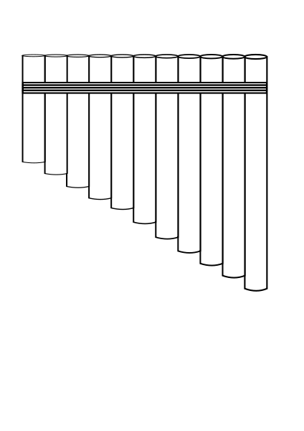(i) Calculate the length of this pipe. (2 marks)

(ii) Calculate the frequency of the fundamental note (first harmonic) produced by the pipe 2 “steps” longer than this. (3 marks)

**Question 15 (14 marks)**

In an experiment, the current that passes through two separate resistors is measured as the voltage across them is changed. The results are shown in the graph below:



(a) State whether ***either, both or none*** of the tested resistors are ohmic. Explain your answer. (2 marks)

(b) Using the graph, determine the resistance of each, R1 and R2. Be sure to show your working. (4 marks)

R1 = ________________ R2 = ________________

(c) If the resistors are now joined in ***series***, plot and clearly label their combined resistance (Rc) on the graph on the previous page. (3 marks)

(d) If the current running through the series circuit is 1.80 A, determine the potential difference of the battery powering the circuit. (2 marks)

(e) The two resistors are now placed in ***parallel*** to the battery. An ammeter is placed in position to measure the current passing through R1 and a voltmeter is in position to measure the potential difference across R2. Draw a labelled diagram of the circuit as described.

(3 marks)

**Question 16 (13 marks)**

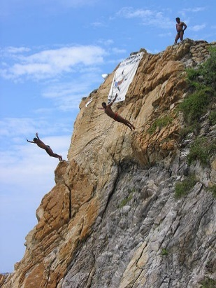The La Quebrada Cliff Divers are a group of professional high divers based in Acapulco, Mexico. They regularly dive head first from a height of 36.0 m into a narrow inlet of ocean water. The water depth varies from 1.80 m - 4.90 m as the ocean waves surge in and out of the inlet. The average depth is 3.60 m.

(a) A diver jumped from the cliff with an initial vertical velocity of 3.50 ms-1 upwards and falls 36.0 m, striking the water when the wave is at its maximum depth. Calculate:

(i) the impact velocity with the water. (3 marks)

(ii) the kinetic energy of a 60.0 kg diver at the instant he reached the water. (2 marks)

(b) (i) If he came to stop at a depth of 3.00 m, what work must be done by the water to stop him? (2 marks)

(ii) Determine the average vertical force exerted by the water onto the diver. (2 marks)

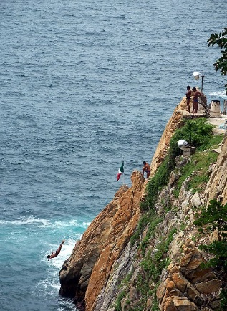(c) The divers time their dive by observing the waves at the entrance of the inlet, to their right. The aim is to land as the wave passes under them, hence the water is at a maximum depth.

(i) Calculate how long it takes for the diver to reach the water when the wave is at its maximum depth. (2 marks)

(ii) The waves move at a constant velocity of 12.0 ms-1. How far away from the impact zone must it be so that the diver lands on top of it? (2 marks)

**Question 17 (12 marks)**

A circuit consisting of a 9.00 V power source and four resistors is shown below. When the switch is ***open***, the total current in the circuit is 0.960 A.

4.00 Ω

X

3.15 Ω

2.00 Ω

9.00 V

(a) Calculate the resistance value of the resistor labelled X. (4 marks)

(b) Calculate the total amount of power used by the circuit when the ***switch is open***.

(2 marks)

(c) Calculate the total resistance of the circuit when the ***switch is closed***. (4 marks)

(d) Calculate the total current in the circuit when the switch is closed. (2 marks)

**Question 18 (16 marks)**

When an object such as a metal rod is heated, its length will almost always increase. A measure of the rate at which this increases is called the coefficient of linear expansion. It is the fractional change in length per degree of temperature change, and can be expressed as:

{\displaystyle \alpha _{L}={\frac {1}{L}}\,{\frac {dL}{dT}}}

where   is the initial length of the sample material.

{\displaystyle L} is the amount by which it has expanded.

{\displaystyle dL/dT} is the change in temperature.

This equation works well as long as the linear-expansion coefficient does not change much over the change in temperature {\displaystyle \Delta T}and the fractional change in length is small.{\displaystyle \Delta L/L\ll 1}{\displaystyle {\frac {\Delta L}{L}}=\alpha _{L}\Delta T}

In an experiment to determine the coefficient of linear expansion of aluminium, a sample of

known length, 6.00 x 102 mm, was placed in a sealed chamber and heated with steam at

1.00 x 102 °C, then allowed to cool. The length of the bar was recorded for each drop of 2.0 °C until the temperature inside the chamber reached 50.0 °C.

(a) Explain, using the kinetic particle model of matter, why substances expand when heated.

(2 marks)

(b) State what assumption must be made when collecting data for the temperature of the sample. (1 mark)

The results for the experiment until the temperature = 80.0 °C are as follows:

|  |  |  |
| --- | --- | --- |
| **ΔTemp (oC)** | **(mm)** |  |
| -1 | 0.99 | 0.00165 |
| -4 | 0.97 | 0.00161 |
| -6 | 0.94 | 0.00157 |
| -8 | 0.92 |  |
| -10 | 0.90 | 0.00151 |
| -12 | 0.87 | 0.00145 |
| -16 | 0.82 | 0.00136 |
| -18 | 0.79 |  |
| -20 | 0.77 | 0.00128 |

(c) Complete the third column, in the table above. Some values are already done. (2 marks)

(d) On the graph paper provided, plot a graph of on the y-axis and ΔT on the x-axis. You must label your axes. (A spare grid is supplied at the end of the paper) (4 marks)

prac exam youngs mod 10 by 10

(e) Draw the line of best fit for your data. (1 mark)

(f) Using your line of best fit, calculate the coefficient of linear expansion for the sample used. Show all relevant calculations and working. (4 marks)

(g) The theoretical value of αL for Aluminium is 23.8 x 10-6 °C-1. Calculate the percentage error in the experimental value obtained.

***(If you were unable to calculate a value for part (f), use 23.0 x 10-6 °C-1.)*** (2 marks)

**Question 19 (8 marks)**

Fuses provide a way of protecting people against electrocution. They are generally a short length of wire that is designed to melt when the current in the circuit exceeds a certain amount.

(a) Describe why the wire will melt when a high current passes through it. (2 marks)

(b) Explain what would have to happen to the resistance of a circuit for the current to increase, and what might cause this to happen. (2 marks)

(c) In a house, a lighting circuit might use a 20.0 A fuse, whilst an oven would use 40.0 A. State which of these circuits would use a fuse with a thicker wire. (1 mark)

Answer ___________________

(d) State one disadvantage of fuses, compared to a residual current device (RCD). (1 mark)

(e) List two other electrical safety devices or features commonly used in a home. (2 marks)

•

•

**End of Section 2**

**Section Three: Comprehension 17% (30 Marks)**

This section contains **two (2)** questions. You must answer both questions. Write your answers in

the space provided. Suggested working time for this section is 40 minutes.

**Question 20 (12 marks)**

**Staying warm in the Arctic**

Inuit people are a collection of indigenous people who live in the Arctic regions of Greenland, Canada and Alaska. In the Arctic, the temperature in winter ranges from -35 °C to 0 °C, but it can drop as low as -50 °C. During the summer, temperatures range from -10°C up to 10°C.

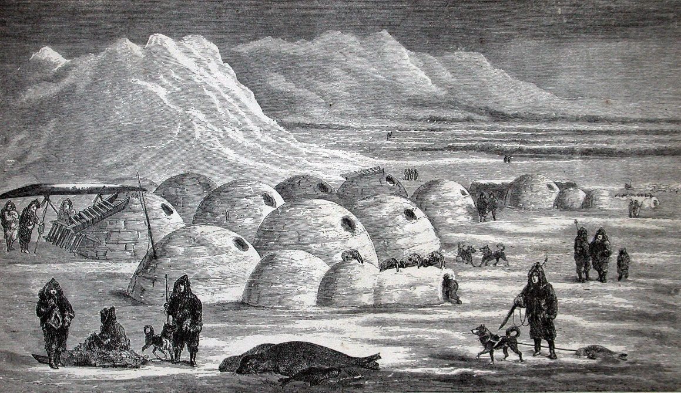

Figure 1: Illustration of an Inuit village

On winter hunting trips, the Inuit people used to live in temporary shelters called igloos. Igloos are made from compressed snow, which is chopped into large blocks that are then stacked in a dome shape. Compressed snow is used as it contains many small air pockets inside, making it a good insulator.

Inside the igloo, the floor is uneven, with a raised section for sleeping on (see Figure 2). The entrance area acts as a ‘cold trap’, whereas the sleeping area holds any heat generated by stoves, lamps or body heat. Inside the igloo, temperatures can range from −7 °C to 16 °C when warmed by body heat alone. Igloos also have a small ventilation hole to allow smoke from lamps to escape.

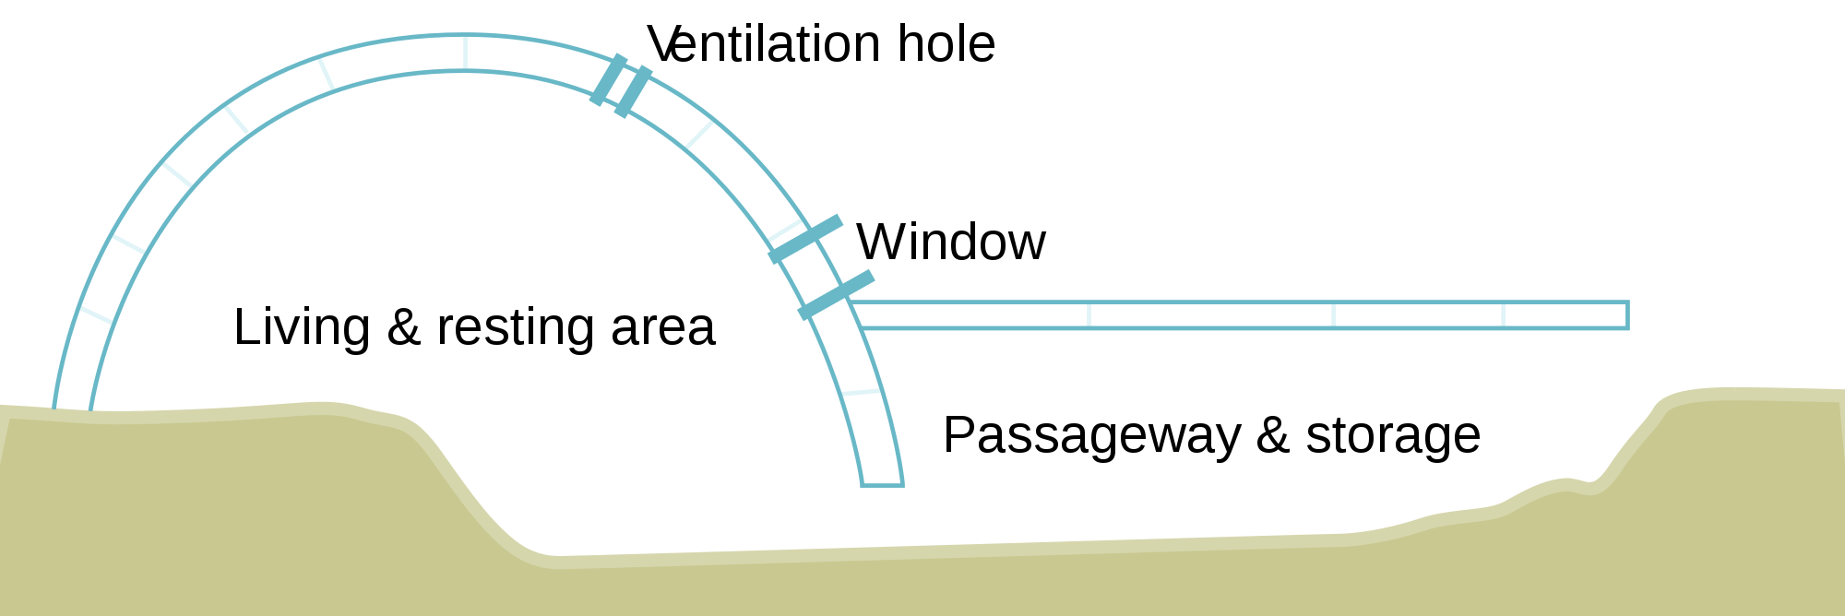

Figure 2: Diagram showing the inside of an igloo

(a) Explain why the raised sleeping area would ‘hold any heat’ and be warmer than sleeping on the lower level. (3 marks)

(b) Explain why compressed snow is a better insulator than a solid ice block. (3 marks)

(c) Explain why the igloo does not completely melt, even when the air temperature inside the igloo is 16 °C. (2 marks)

(d) Calculate the amount of energy needed to melt an entire igloo that is at -10.0 °C. The igloo is made of 150 blocks, each with a volume of 0.0500 m3. Compressed snow has a density of 2.00 x 102 kgm-1. (4 marks)



**Note:**

**Question 21 (18 marks)**

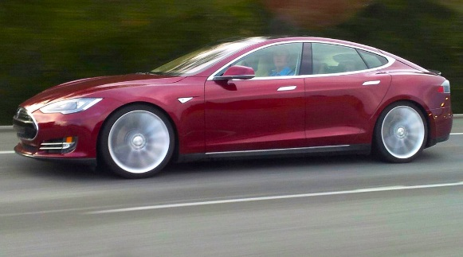

The Tesla model S, is an electric vehicle that the manufacturer claims is the third-fastest production car ever, with an acceleration of 0-100 kmh-1 in 2.70 seconds. It has a mass of 2108 kg, of which 544 kg is the battery packs.

The 2012 Model S P90D came equipped with an 85.0 kWh battery pack that is arranged in modules, spread under the floor of the vehicle. The 11 modules each have 9 x 3.60 V “bricks” arranged in series. This model has a stated range of 410 km on a full charge. The Environmental Protection Authority (EPA) measured its average energy consumption at 237.5 watt-hours per kilometre or 23.75 kWh/100 km, for a combined fuel economy of 2.64 L/100 km equivalent.

The vehicle is charged by simply plugging it into a source of electricity, not unlike a mobile phone. The standard on-board charger accepts 120 or 240 Volt sources at a rate of up to 10.0 kW. An optional US$2,000 upgrade for a second 10.0 kW on-board charger supports a total of up to

20.0 kW, charging from an 80.0 A Tesla Wall Connector.

(a) Calculate the stated acceleration of the Tesla Model S. (2 marks)

(b) Calculate the average force exerted by the engine to produce this acceleration.

(2 marks)

(c) Calculate the total EMF (voltage) of the Model S P90D’s battery pack. (2 marks)

(d) The kilowatt-hour (kWh) is a unit used to measure energy and is the amount of energy used by a 1.00 kW machine in 1 hour. Calculate the capacity of the Model S P90D’s battery pack, in Joules. (3 marks)

(e) Calculate the range of the model S P90D, based upon the EPA’s testing. How does this compare to the manufacturer’s claims? (4 marks)

(f) When charging from a 2.40 x 102 V source at 10.0 kW, calculate how much current is being drawn by the charger. (2 marks)

(g) Calculate the minimum time it would take to recharge a flat battery when using the

standard on-board charger. (3 marks)

**End of Questions**

**Additional working space**

**Spare grid for graph**

prac exam youngs mod 10 by 10

**Additional working space**

**Additional working space**

**Additional working space**

**End of examination**